Given the root of a binary tree, return *the average value of the nodes on each level in the form of an array*. Answers within 10-5 of the actual answer will be accepted.

**Example 1:**

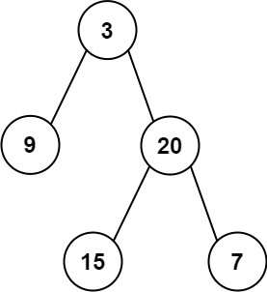

**Input:** root = [3,9,20,null,15,7]

**Output:** [3.00000,14.50000,11.00000]

Explanation: The average value of nodes on level 0 is 3, on level 1 is 14.5, and on level 2 is 11.

Hence return [3, 14.5, 11].

**Example 2:**

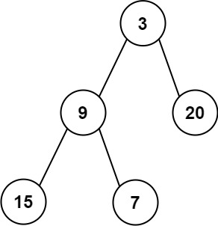

**Input:** root = [3,9,20,15,7]

**Output:** [3.00000,14.50000,11.00000]

**Constraints:**

* The number of nodes in the tree is in the range [1, 104].
* -231 <= Node.val <= 231 - 1